INTRODUCTION

1. Introduction to LINUX
Linux is an UNIX like operating system that runs on many different computers. Linux was first released in 1991 by Linus Torvalds, at the university of Helsinki. It is an open source code written completely using C language.

Linux is popular with today’s generation of computer user for the same reason early versions of the Unix operating system enticed fans more than 20 years ago. Linux is portable, which means you will find versions running on name brand or clone PC’s, Apple Macintoshes, Sun workstation or Alpha based computers. Linux also comes with source code, so you can change or customize the software to adapt to your needs.

2. Introduction to SHELL
Shell is the main content of the operating system and it is often called command line interpreter. Shell is the between kernel and user. The shell and the kernel are very well related to each other. The kernel hides itself from the user and the shell is the main user interface.

The following are different command line shells available in Unix/Linux systems:
- Bourne Shell ($)
- C Shell (%)
- Korn Shell (#)
- Bash Shell (an improved Borne shell with history and aliases)

3. Kernel and Shell Relation:
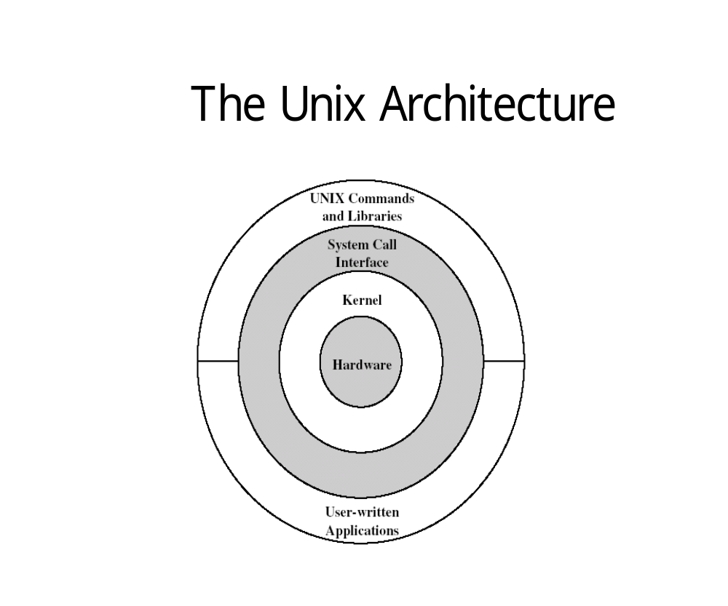We observe in the diagram that the Shell provides an opportunity for the programmer to run multiple programs in the same system on the single kernel.

Types of commands:
Internal commands are built in commands.
Ex: echo.
External commands are commands with independent existence.
Ex: ls

REQUIREMENTS

- HARDWARE REQUIREMENTS
  - CPU requirements-Pentium 100MHz or higher.
  - Memory requirements-1Mb RAM (min).
  - Operating system-Linux.

- SOFTWARE REQUIREMENTS
  - Linux platform.
  - C compiler.

DESIGN

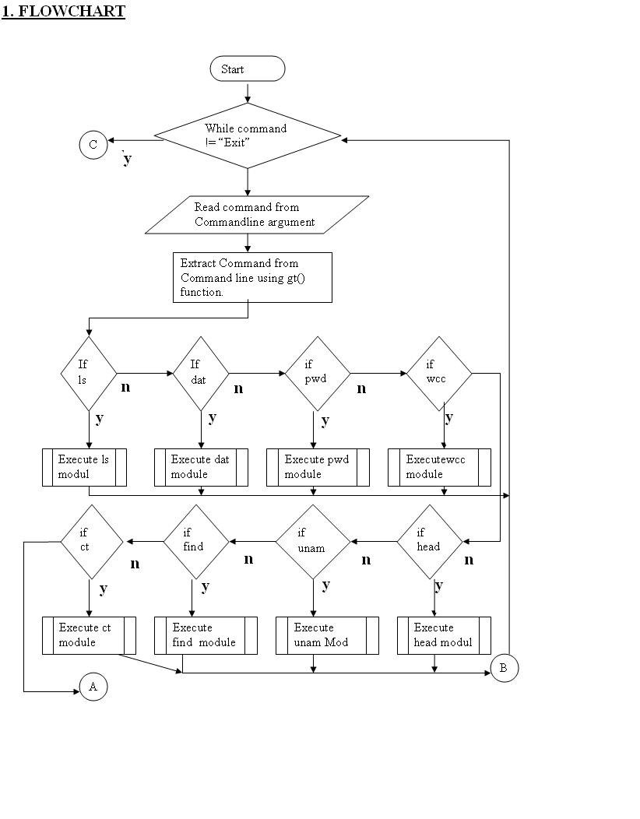

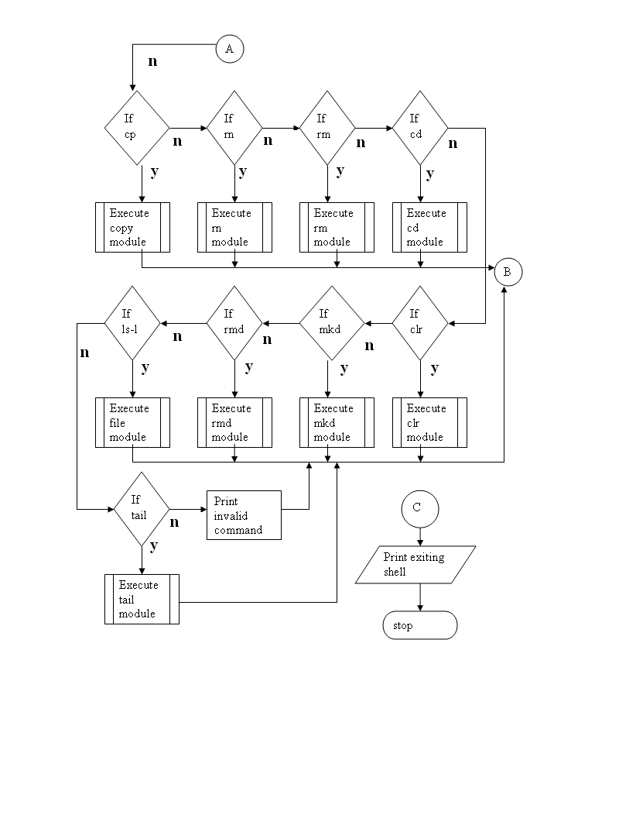

2. ALGORITHM

- Start
- The function cmd gets the filename given by the user after the command.
- The command is read character by character and stored in a variable till a space is encountered.
- Once a space is encountered the followed filename is read and stored in another variable.
- The function gt gets the command line.
- In the main module, the command given will be compared with the string and the respective function is called to perform the operation.
- If this fails the quit module is called which has string handling function, perror that displays the error message.
- Linux sub-shell is implemented which works for about 10-12 commands.

3. EXECUTION OF SHELL COMMANDS.

Each user is presented with a Shell. This is a program, which displays the
users prompt, handles users input and displays output on the terminal.

The Shell program provides mechanism for customizing each user’s setup requirements, and storing this information for re-use i.e., in the file.profile.

PICTORICAL REPRESENTATION

Shell displays
prompt
Shell reads user commands
Shell ‘forks’ a
Process for ‘ls’
‘ls’ interfaces
With user
$_
$ ls
$ ls
Profile

IMPLEMENTATION

List of all header files, API’s and individual modules used in our project.

1. HEADER FILES :

No | Header files | Description
01  02  03  04  05  06  07  08  09  10  11  12 | <stdio.h>  <string.h>  <time.h>  <dirent.h>  <ctype.h>  <stdlib.h>  <pwd.h>  <fcntl.h>  <sys/types.h>  <sys/stat.h>  <sys/wait.h>  <sys/utsname.h> | Includes standard I/O library.  Includes string operations.  Includes time and date.  Includes directory entries.  Includes character types.  Includes utility files.  Includes password files.  Include file control.  Includes primitive system data types.  Includes file status.  Includes process control.  Includes system name.

Primitive System Data Types:
The header <sys/types.h> defines some implementation-dependent data types, called the primitive system data types.

TYPE DESCREPTION
clock_t counter of clock ticks (process time)
comp_t compressed clock ticks.

TYPE DESCRIPITION

dev_t device number
fd_set file description sets
fops_t file position
ino_t inode number
mode_t filetype,file creation mode.
size_t sizes of objects (such as strings)(unsigned)
ssize_t function that returns a count of bytes (signed)
time_t counter of seconds of calendar tlme.

2. APPLICATION PROGRAM INTERFACE (API’s):
getcwd:
#include<unistd.h>
char *getcwd(char *buf, size_t size);

Returns: buf if OK, NULL on error.

This function starts at cwd(dot) and works its wat up the directory hierarchy. At each directory it reads the directory entries until it finds the name that correspond to the I-node of the directory. Repeating this procedure until the root is encountered yields absolute pathname of cwd.

chdir:
#include<unistd.h>
int chdir(const char *pathname);

Returns: 0 if OK, -1 on error.

We can change the current working directory of the calling process by calling the chdir function.
time:
#include<time.h>
time_t time(time_t *cal);

Returns: value of time if OK, -1 on error.

Function time returns the current date and time.

Localtime and gmtime:
#include<time.h>
struct tm *gmtime(const time_t *cal);
struct tm *localtime(const time_t *cal);

Returns: pointer to broken down time.

Functions gmtime and localtime converts a calendar time into a tm structure (broken down time).
Broken down structure:
struct tm
{
int tm_sec;
int tm_min;
int tm_hour;
int tm_mday;
int tm_mon;
int tm_year;
int tm_wday;
int tm_yday;
int tm_isdst;
}

strftime:
# include<time.h>
size_t strftime(char *buf,size_t maxsize, const char *format, const struct tm *tmptr);

Return: number of character stored in array else 0.

The function strftime is similar to printf statement but it is for time values.
The final arguments is the time value to format, specified by pointer to a broken down time value, the formatted result is stored in ‘buf’ whose size is ‘maxsize’.
If the result, including’\o’ ,fits the buffer, the function return the number of character stored in buf else 0[zero].

Format description example
%a weekday name tue
%A full weekday name tuesday
%b month name jan
%B full month name january
%c date & time tue jan 14 19:40:30 2005
%d day of the month 14
%j day of the year 014
%p AM/PM Am
%X date 10/11/2005
%z time zone name IST

mkdir:
# include<sys/stat.h>
# include<unistd.h>
int mkdir(const char *path_name , mode_t mode):
Returns: 0 if succeed and –1 if fails.

This API is used to make new directory. Path_name of directory file to be created, the mode argument specifies the access permission for owner, group and others.

Modes of access:
S_IRWXU = S_IRUSR | S_IWUSR | S_IXUSR
S_IRWXG = S_IRGRP | S_IWGRP | S_IXGRP
S_IRWXO = S_IROTH | S_IWOTH | S_IXOTH

rmdir:
# include<unistd.h>
int rmdir(const char* path_name);

Returns: 0 if OK , -1 on error.

This API is used to remove the directory.

stat:
# include<sys/stat.h>
#include<unistd.h>
int stat(const char *path_name, struct stat *start);
Returns: 0 if succeed, -1 on error.
This API retrive the file attributes of a given file.
struct stat
{
dev_ts t_dev; /* file system id*/
ino_t st_ino; /* file i-node num */
mode_t st_mode; /* contains file types & acces flags */
nlink_t st_nlink; /* hard link count */
uid_t st_uid; /* file user id */
gid_t st_gid; ; /* file group id */
dev_t st_rdev; /* major &minor device number */
off_t st_size; /* file size in num of bytes */
time_t st_atime; /* last access time */
time_t st_mtime; /* last modification time */
time_t st_ctime; /* lost status change time */
};

lstat:
int lstat(const char*path_name, struct stat* star);

Lstat API can be used to obtain attributes of symbolic link files. If path_name argument to lstat is a symbolic link file then lstat will return the symbolic link file attributes but not the file if refers to.

utsname:
#include<sys/utsname.h>
int name(Struct utsname *nam);
Returns: non-negative value if OK else -1

struct utsname
{
char sysname[9];
char modename[9];
char release[9];
char version[9];
char machine[9];
};

open:

#include<sys/types.h>
#include<fcntl.h>
int open(const char* path_name, int access_mode, mode_t permission);
Returns: File descriptor if OK, -1 on error.

Open API establishes a connection between a process and a file. First argument path_name is the pathname of a file and second argument access_mode is an integer value that specifies how a file is to be accessed by calling process. Access modes are defined in fcntl.h.

ACCESS MODE FLAG USE
O_RDONLY OPENS THE FILE FOR READ ONLY
O_WRONLY OPENS THE FILE FOR WRITE ONLY
O_RDWR OPENS THE FILE FOR WRITE & READ

Third argument is required only if the O_CREAT flag is set in the access_mode argument.
O_CREAT = creates the file if it does not exit.

creat:
# include<sys/types.h>
#include< unistd.h>
int creat(const char*path_name,mode_t mode);
Returns: file descriptor opened for write only if OK, -1 on error.

Creat API creates a new file if specified file is not there.

read :
.
#include<sys/types.h>
#include<unistd.h>
ssize_t read(int fd, void *buf, size_t size);
Returns: number of bytes read, 0 if EOF, -1 on error.
Read API fetches a fixed size block of data from a file referenced by a given descriptor. First argument ‘fd’ is an file descriptor that refers to an opened file. Second argument is the address of a buffer holding any data read. Third argument specifies how many bytes of data are to be read from the file.

write:
# include<sys/types.h>
# include<unistd.h>
size_t write(int fdesc, const void *buf, size_t size);
Return num of bytes written if OK ,-1 on error.

Write API puts a fixed size block of data to a file referenced by a file descriptor. The arguments are similar to read function. For a regular file, the write starts at the file’s current offset. After successful write, the file’s offset is incremented by number of bytes actually written.

close:

# include<unistd.h>
int close(int fdesc);
Returns: 0 if OK , -1 on error.

Close API is used to close an opened file. Closing a file also releases any record locks that the process may have on the file.When process terminates, all open files are automatically closed by the kernel.

remove:
#include<stdio.h>
int remove(const char *path_name);
Returns: 0 if OK, -1 on error.

Remove API removes the specified file mentioned in the path_name argument.

rename:
# include<stdio.h>
int rename(const char *oldname, const char *newname);
Returns: 0 if OK, else -1 on error

Rename API renames a file by replacing its old name with its new name.

3. INDIVIDUAL MODULES.

Module 1 ::gt()
- This module scans for the arguments followed by the command input.
- The format of the command line is command options filename.

Module 2:: ls()
- The directory structure used in the module has the inode number and the filename.
- If the directory opened is not NULL, then the output has the inode numbers and filename.

Module 3:: ls-l()
- If the directory is not empty, it prints the file attributes.

- It prints the mode of file, links ,uid, gid, size of the file, last modified time, filename.

Module 4:: head()
- The command is to get the first ten lines of the file.
- The input file is opened in read mode.
- Using fget function the contents of the file are got.
- While it is not the end of the file, print the first ten lines of the file.
- Increment the pointer.

Module 5:: tail()
- The command is to get the last ten lines of the file.
- The input file is opened in the read mode.
- Using fgets function the contents of the file is obtained.
- Decrement the pointer so that its points to the last line of the file, and prints the last ten lines.
- Modules implemented should also be able to print the lines even if he file has less than ten lines.

Module 6 :: date()
- This command prints the current day, month, date, time and year.
- The format of time printed is hh:mm:ss.
- This is included in the header file <time.h>.

Module 7 :: pwd()
- Using the “getcwd” function, we get the current working directory.
- Prints the directory.

Module 8 :: mkdir()
- Specify the directory to be created.
- Function call “mkdir”, does the operation.
- The created directory can be viewed using ls command.

Module 9 :: rmdir()
- Specify the directory to be removed.
- Function call “rmdir”, removes the directory.

Module 10 :: cat()
- The command has been implemented to display the contents of the file.
- Input file is opened in the read mode.
- Using fgets function the contents of the file are displayed.
- While not end of the file, the contents are displayed.

Module 11 :: wc()
- This command counts the occurrence of lines, words, and characters.
- File is opened in the read mode.
- Using fgetc function gets the characters and assigns it to a variable.
- While not end of the input count the occurrences of the above mentioned and print it.

Module 12 :: grep()
- This command finds the pattern in the given file.
- Opens the file in a read mode.
- Displays all the occurrence of the pattern in the file.

Module 13 ::cp()
- This command opens the file in read mode.
- And copy the contents of opened file into another file that is opened in write mode.

Module 14 :: rm()
- This command removes the specified file.
- This uses function call “rm”.

Module 15 :: rename()
- This command has been implemented to rename the specified file.
- This command needs both new and old names of the file to be renamed.
- Function call “rename”, does the operation.

Module 16 :: uname()
- This command displays certain features of the OS.
- This module displays the name of the OS, version, machine name and release.

Module 17 :: clear()
- Call the system call “clear”.
- It clears the entire screen.

CODING

/*KKSHELL*/
#define CMDLEN 50
#define ARGLEN 25
#define PATH_LENGTH 100

/*HEADER FILES*/
#include<sys/types.h>
#include<sys/stat.h>
#include<stdio.h>
#include<time.h>
#include<string.h>
#include<dirent.h>
#include<sys/utsname.h>
#include<wait.h>
#include<fcntl.h>
#include<ctype.h>
#include<pwd.h>
#include<stdlib.h>
#include<unistd.h>

/*GLOBAL VARIABLES*/
char cmd[CMDLEN];
char arg1[ARGLEN],arg2[ARGLEN];

/*FUNCTION DECLARATION*/
void kexit();
void klogin();
void getcmd(char cmdname[]);
void getargs();
void kdate();
void kmd();
void krd();
void kren();
void kcat();
void kcatp();
void kls();
void klsp();
void kclear();
void kpwd();
void kwc();
void khead();
void ktail();
void kwhoami();
void kuname();
void kcp();
void kcd();
void kabout();
void kman();

/*MAIN FUNCTIONS*/
int main()
{
char cmdname[10];
kclear();
klogin();
do
{
printf("\n[KKshell]@");
gets(cmd);
getcmd(cmdname);
getargs();
if(strcmp(cmdname,"kls")==0 && strcmp(arg1,"-p")==0)
klsp();
else if(strcmp(cmdname,"kls")==0)
kls();
else if(strcmp(cmdname,"kren")==0)
kren();
else if(strcmp(cmdname,"kdate")==0)
kdate();
else if(strcmp(cmdname,"kcd")==0)
kcd();
else if(strcmp(cmdname,"khead")==0)
khead();
else if(strcmp(cmdname,"ktail")==0)
ktail();
else if(strcmp(cmdname,"kcat")==0 && strcmp(arg1,"-p")==0)
kcatp();
else if(strcmp(cmdname,"kcat")==0)
kcat();
else if(strcmp(cmdname,"kclear")==0)
kclear();
else if(strcmp(cmdname,"kmd")==0)

kmd();
else if(strcmp(cmdname,"krd")==0)
krd();
else if(strcmp(cmdname,"kpwd")==0)
kpwd();
else if(strcmp(cmdname,"kwc")==0)
kwc();
else if(strcmp(cmdname,"kwhoami")==0)
kwhoami();
else if(strcmp(cmdname,"kuname")==0)
kuname();

else if(strcmp(cmdname,"kcp")==0)
kcp();
else if(strcmp(cmdname,"kman")==0)
kman();
else if(strcmp(cmdname,"about")==0)
kabout();
else if(strcmp(cmdname,"exit")==0)
kexit();
else if(cmdname[0]!=0)
printf("\n\a\a\aKERROR:COMMAND NOT FOUND");
}while(strcmp(cmdname,"exit")!=0);
return;
}

/*Function to check login and password*/
void klogin()
{
char login[20];
char pass[20];
while(1)
{
printf("\nLOGIN NAME:");
scanf("%s",login);
printf("PASSWORD");
scanf("%s",pass);
if(strcmp(pass,"kkshell")==0)
{
printf("\nLOGIN SUCESSFULL\nWELCOME TO KKSHELL");
return;
}
else
printf("\n\a\a\aKERROR:WRONG PASSWORD\nENTER AGAIN");
}
}

/*FUNCTION TO EXIT KKSHELL*/
void kexit()
{
printf("\n\a\aTERMINATING KKSHELL........\n");
exit(0);
}

/*FUNCTION TO GET THE COMMAND NO*/
void getcmd(char cmdname[])
{
int i;
for(i=0;cmd[i]!=' ' && cmd[i]!=0;i++)
cmdname[i]=cmd[i];
cmdname[i]=0;
return;
}

/*FUNCTION TO GET ARGUMENTS*/
void getargs()
{

arg1[0]=0;
arg2[0]=0;
int i,k;
for(i=0;cmd[i]!=' '&& cmd[i]!=0;i++);
if(cmd[i]!=0)
{
i++;
}
for(k=0;cmd[i]!=' ' && cmd[i]!=0;i++,k++)
{
arg1[k]=cmd[i];
}
arg1[k]=0;
if(cmd[i]!=0)
{
i++;
}

for(k=0;cmd[i]!=' ' && cmd[i]!='\0';i++,k++)
{
arg2[k]=cmd[i];
}
arg2[k]=0;

return;
}

/*FUNCTION TO DISPLAY DATE AND TIME*/
void kdate()
{
time_t tvar=time(0);
printf("\n%s",ctime(&tvar));
return;
}

/*FUNCTION TO CREATE NEW DIRECTORY*/
void kmd()
{
getargs();
if(mkdir(arg1,000)!=0)
printf("\n\a\a\aKERROR:UNABLE TO CREATE DIRECTORY");
else
printf("\nDIRECTORY CREATED SUCCESSFULLY");
return;
}

/*FUNCTION TO DELETE DIRECTORY*/
void krd()
{
getargs();
if(rmdir(arg1)!=0)
printf("\n\a\a\aKERROR:DIRECTORY NOT FOUND");
else
printf("\nDIRECTORY DELETED SUCCESSFULLY");
return;
}

/*FUNCTION TO RENAME DIRECTORY AND FILES*/
void kren()
{
getargs();
if(rename(arg1,arg2)!=0)
printf("\n\a\a\aKERROR:UNABLE TO RENAME");
else
printf("\nRENAMED SUCCESSFULLY");
return;
}

/*FUNCTION TO DISPLAY CONTENTS OF A FILE*/
void kcat()
{
char ch;
FILE *fp;
getargs();
if((fp=fopen(arg1,"r"))==NULL)
printf("\n\a\a\aKERROR:UNABLE TO OPEN FILE");
else
{
ch=fgetc(fp);
while(ch!=EOF)
{
printf("%c",ch);
ch=fgetc(fp);
}
fclose(fp);
}
return;

}

/*FUNCTION TO DISPLAY CONTENTS OF A FILE PAGEWISE*/
void kcatp()
{
char ch,flag;
FILE *fp;
int i;
getargs();
if((fp=fopen(arg2,"r"))==NULL)
printf("\n\a\a\aKERROR:UNABLE TO OPEN FILE");
else
{
ch=fgetc(fp);
for(i=0;ch!=EOF;)
{
if(ch=='\n')
i++;
printf("%c",ch);
ch=fgetc(fp);
if(i%34==33)
{
printf("\nPRESS ENTER TO CONTINUE");
getchar();
i++;
}
}
fclose(fp);
}
return;

}

/*FUNCTION TO LIST ALL FILES AND DIRECTORIES*/
void kls()
{
DIR *dir_fdesc;
struct dirent *dp;
int i;
getargs();
if(arg1[0]==0)
strcpy(arg1,".");
if((dir_fdesc=opendir(arg1))==NULL)
printf("\n\a\a\aKERROR:DIRECTORY DOES NOT EXIST");
else
{
printf("\nNO.\tNAME");
for(i=1;(dp=readdir(dir_fdesc))!=NULL;i++)
{
printf("\n%d.\t%s",i,dp->d_name);
}
}
return;
}

/*FUNCTION TO LIST ALL FILES AND DIRECTORIES PAGE WISE*/
void klsp()
{
DIR *dir_fdesc;
struct dirent *dp;
int i;
getargs();
if(arg2[0]==0)
strcpy(arg2,".");
if((dir_fdesc=opendir(arg2))==NULL)
printf("\n\a\a\aKERROR:DIRECTORY DOES NOT EXIST");
else
{
printf("\nNO.\tNAME");
for(i=1;(dp=readdir(dir_fdesc))!=NULL;i++)
{
printf("\n%d.\t%s",i,dp->d_name);
if(i%34==33)
{
printf("\nPRESS ENTER TO CONTINUE");
getchar();
}
}
}
return;
}

/*FUNCTION TO CLEAR THE SCREEN*/
void kclear()
{
system("clear");
return;
}

/*FUNCTION TO GET PRESENT WORKING DIRECTORY*/
void kpwd()
{
char curdir[PATH_LENGTH];
getcwd(curdir,PATH_LENGTH);
printf("\nPRESENT WORKING DIRECTORY: %s",curdir);
return;
}

/*FUNCTION TO COUNT LINES,WORDS CHARACTERS*/
void kwc()
{
int lines=0,words=0,chars=0,flag=0;
char ch,prev;
FILE *fp;
getargs();
if((fp=fopen(arg1,"r"))==NULL)
printf("\n\a\a\aKERROR:UNABLE TO OPEN FILE");
else
{
ch=fgetc(fp);
prev=ch;
while(ch!=EOF)
{
if(ch=='\n')
{
lines++;
chars++;
if(prev!='\n' && prev!=' ')words++;
}
else if(ch==' ' && prev!=' ' &&prev!='\n')
{
words++;
chars++;
}
else
{
chars++;
}
prev=ch;
ch=fgetc(fp);

}
printf("\nLINES:%d\tWORDS:%d\tCHARACTERS:%d",lines,words,chars);
fclose(fp);
}
return;
}

/*FUNCTION TO DISPLAY LINES FROM BEGINNING*/
void khead()
{
FILE *fp;
int lines=0,i,j;
char ch;
getargs();
if(arg2[0]==0)
lines=10;
else
{
for(i=0,j=1;arg2[i]!='\0';i++,j=j*10)
{
lines=lines*10;
lines=lines+arg2[i]-'0';
}
}
if((fp=fopen(arg1,"r"))==NULL)
printf("\n\a\a\aKERROR:UNABLE TO OPEN FILE");
else
{
for(i=0;i<lines && ch!=EOF;)
{
ch=fgetc(fp);
printf("%c",ch);
if(ch=='\n')
i++;
}
fclose(fp);
}
return;
}

/*FUNCTION TO DISPLAY LINES FROM END*/
void ktail()
{
FILE *fp;
int lines=0,i,j,ln=0;
char ch;
getargs();
if(arg2[0]==0)
lines=10;
else
{
for(i=0,j=1;arg2[i]!='\0';i++,j=j*10)
{
lines=lines*10;
lines=lines+arg2[i]-'0';
}
}
if((fp=fopen(arg1,"r"))==NULL)
printf("\n\a\a\aKERROR:UNABLE TO OPEN FILE");
else
{
ch=fgetc(fp);
while(ch!=EOF)
{
if(ch=='\n')
ln++;
ch=fgetc(fp);
}
ln=ln-lines;
if(ln<0)
{
printf("\nKERROR:GIVE LESS LINES");
return;
}
fclose(fp);
fp=fopen(arg1,"r");
for(i=0;i<ln;)
{
ch=fgetc(fp);
if(ch=='\n')
i++;
}
ch=fgetc(fp);
for(i=0;i<lines && ch!=EOF;)
{
printf("%c",ch);
if(ch=='\n')
i++;
ch=fgetc(fp);
}

fclose(fp);
}
return;
}

/*FUNCTION FOR WHO AM I*/
void kwhoami()
{
struct passwd *pw;
pw=getpwuid(getuid());
printf("\nLogin Name:%s",pw->pw_name);
return;
}

/*FUNCTION TO DISPLAY,OS VERSION AND MACHINE*/
void kuname()
{
struct utsname sys;
uname(&sys);
printf("\nOS:%s",sys.sysname);
printf("\nOS release:%s",sys.release);
printf("\nVersion of Release:%s",sys.version);
printf("\nHardware Type:%s\n",sys.machine);
return;
}

/*FUNCTION TO COPY CONTENTS OF FILE*/
void kcp()
{
char ch;
FILE *fp1,*fp2;
getargs();
if((fp1=fopen(arg1,"r"))==NULL)
printf("\n\a\a\aKERROR:UNABLE TO OPEN SOURCE FILE");

else if((fp2=fopen(arg2,"w"))==NULL)
printf("\n\a\a\aKERROR:UNABLE TO CREATE DESTINATION FILE");

else
{
ch=fgetc(fp1);
while(ch!=EOF)
{
fputc(ch,fp2);
ch=fgetc(fp1);
}
printf("\nFILE COPIED SUCCESSFULLY");
fclose(fp1);
fclose(fp2);
}
return;
}

/*FUNCTION TO CHANGE DIRECTORY*/
void kcd()
{
char newdir[PATH_LENGTH];
struct passwd *pw;
char olddir[PATH_LENGTH];
getargs();
getcwd(olddir,PATH_LENGTH);
printf("\nPRESENT WORKING DIRECTORY:%s",olddir);
if(arg1[0]=='\0')
{
pw=getpwuid(getuid());
strcpy(arg1,pw->pw_dir);
}
if(chdir(arg1)==-1)
{
printf("\n\a\a\aKERROR:ERROR IN CHANGING DIRECTORY");
return;
}
else
{
printf("\nDIRECTORY CHANGED TO:%s SUCESSFULLY",arg1);
getcwd(newdir,PATH_LENGTH);
printf("\nPRESENT WORKING DIRECTORY:%s",newdir);
}
return;
}

/*COMMAND MANUAL*/
void kman()
{
kclear();
strcpy(cmd," manual.kk");
printf("%s",arg1);
kcat();
return;
}

/*ABOUT US*/
void kabout()
{
kclear();
strcpy(cmd," aboutus.kk");
kcat();
return;
}

SNAPSHOTS

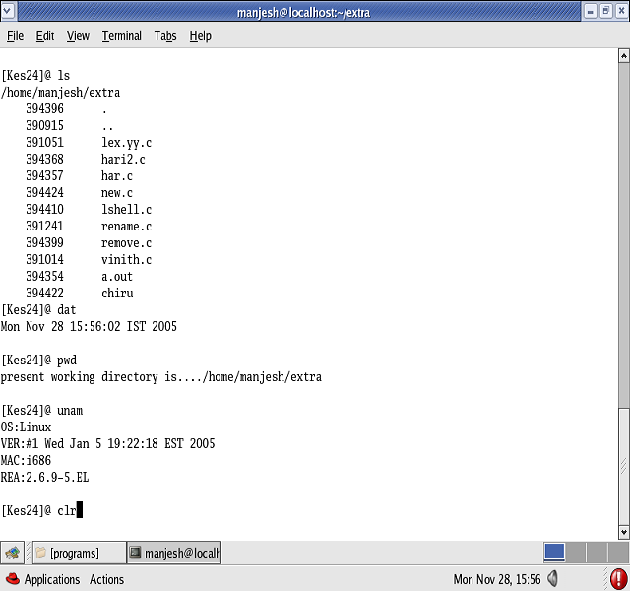

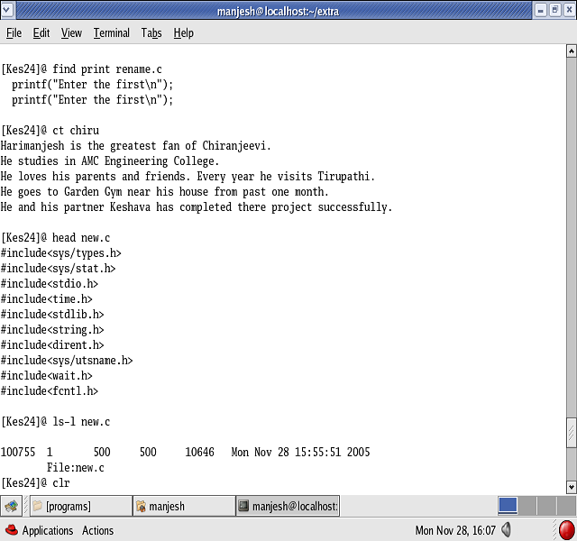

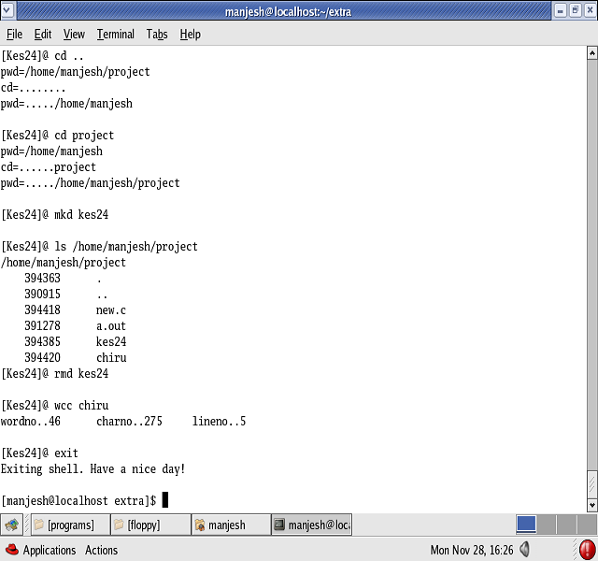

TESTING

Introduction:
Software testing is an important element of software quality of specification design and coding. Testing is a process of executing a program with the intend of finding an error.

Types of Testing:

- System Testing:
Testing is the final phase of the software development and also it is one of the important steps in software Engineering. Where the quality and the reliability of the product is determined. After the system has been satisfactorily coded, the product must be undergoing for a testing process.
Testing should satisfy all requirements specified in the software requirements specification document. After the success of testing it needs to be implemented.

- Unit Testing:
Unit testing is a test of a simple piece of code. As already
mentioned, that the system has been developed by modules wise and the first phase of testing must be module wise testing. Checking whether the module works independently and without any bugs and errors. Base module is tested first and then each module is being tested one after the other.

- Integration Testing:
Integration testing is the next level. The module of the
system has been first taken and according to the linkage priority each modules have been
integrated into the system. This integration test is performed in order to verify that the system works according to the requirements even after integration of all modules.

- Performance Testing:
This testing is designed to test the run time performance
of software within the integrated system. This system occurs throughout all steps in the testing process.

Testing information flow:

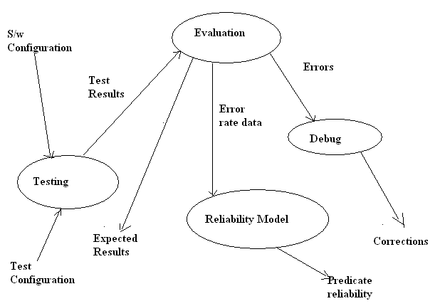

System testing:
Linux shell that we have implemented was successfully executed in many systems on different Linux versions.

Unit testing:

TEST  CASE ID | TEST DESCRIPTION | TEST  DATA | RESULTS |  | REMARK
TEST  CASE ID | TEST DESCRIPTION | TEST  DATA | EXPECTED  RESULT | ACTUAL  RESULT | REMARK
Shell_01 | Function of KLS | kls | Display list of files and directories. | Display list of files and directories. | Pass
Shell_02 | Function of KWC | kwc | Counts number of words | Counts number of words | Pass
Shell_03 | Function of KDATE | kdate | Displays current system date | Displays current system date | Pass
Shell_04 | Function of KUNAME | kuname | Displays OS information | Displays OS information | Pass
Shell_05 | Function of KPWD | kpwd | Displays present working directory. | Displays present  Working directory | Pass
Shell_06 | Checks the function of KMD | kmd | Creates a new directory | Creates a new directory | Pass
Shell_07 | Function of KCD | kcd | Changes directory | Changes directory | Pass
Shell_08 | Function of KRD | krd | Removes directory | Removes directory | Pass
Shell_09 | Function of KCAT | kcat | Displays contents of a file | Displays contents of a file | Pass
Shell_10 | Function of HEAD | khead | Displays first ten lines of a file | Displays first ten lines of a file | Pass
Shell_11 | Function of TAIL | ktail | Displays last ten lines of a file | Displays last ten lines of a file | Pass
Shell_12 | Function of KVI | kvi | Invokes the editor | Invokes the editor | Pass
Shell_13 | Function of KCP | kcp | Copy contents of one file to other. | Copy contents of one file to other | Pass
Shell_14 | Function of  KREN | kren | Renames a specified file | Renames a specified file | Pass
Shell_15 | Function of KMAN | kman | Display summary of commands | Display summary of commands | Pass
Shell_16 | Function of KLSP | kls-p | Displays all files and directories in the specified path | Displays all files and directories in the specified path | pass
Shell_17 | Function of KCLEAR | kclear | Clears screen | Clears screen | pass

CONCLUSION

Through all the features of standard UNIX shell like Bash, Ksh, Csh are not implemented. Most of the standard features of a shell are implemented in the project. During the project work we learnt project management and a host of other things. We are eagerly looking forward to more such projects, where we can implement what we have learnt in the course of graduation. Shell designing broadened our knowledge of UNIX system. We also thoroughly understood the
Concepts of UNIX like process management, file management, numerous system calls and API’s. While doing our project, we referred many UNIX books, which gave deep insight into the UNIX system.
We had good experience throughout our project development. There were many positives and negatives during the course of this project development.

LIMITATIONS

- Options to the ‘ls’ command.

- Options to the ‘grep’ command.

- Options to the ‘head’ and ‘tail’ command.

- Options to the ‘wc’ command.

- Creation and concatenation of file contents using cat command.

FUTURE ENHANCEMENTS

The kes24@ we have implemented is a basic shell which is not developed for existing platforms of LINUX, what we have done is, developed a basic structure of the shell, where the future generation programmers can make use of it.
And we also expect them to develop much advanced, powerful and stable shell, which run on any versions of the LINUX platforms.

We can include the following features as added features of sub-shell:
- Options to the command ‘ls’.
- Options to ‘head’ and ‘tail’ commands.
- Creation of a file using ‘cat’ command.
- Options to ‘grep’ and ‘wc’ command.

Other expected enhancements:
- Supporting many other user’s applications.
- To support GUI.
- Supporting multi-user environment.

BIBLIOGRAPHY

- UNIX system programming using C++ ------ Terrence Chan

- Advanced programming in the Unix Environment ------ Richard Stevens

- UNIX concepts and applications ------ Sumitabha Das

